Droidcon Soldering Project

Droidconuino v1.2

Builders Kit Parts list

Estimated build time: 30 to 60 minutes

Congratulations! You’re going to build your very own DroidCONuino! The DroidCONuino is a variant AdaFruit’s Boarduino, which is from the Arduino UNO. It includes an onboard 1 Amp 5 V DC regulator, 6 Servo connections, a 72xx (Teeces) Logics Bus & an I2C bus for communication with additional devices inside of your Astromech. Optional installation of header pins allows you to mount DroidCONuino into a breadboard to prototype additional cool things. We hope you enjoy your workshop and building your very own DroidCONuino.

QTY ID Description QA Checked?

1 IC1 Atmel 328P MCU 28pin DIP with UNO Bootloader (DigiKey ATMEGA328P-PU-ND)

1 IC2 LM7805CT – 5V DC Regulator Transistor TO-220 (DigiKey LM7805CT-ND)

1 D1 1N4001 Diode (DigiKey 1N4001FSCT-ND) Red tape on one end, white on the other

1 D2 3mm RED LED (DigiKey 160-1708-ND) – LONG LEAD is POSITIVE

1 D3 3mm GREEN LED (DigiKey 160-1710-ND) – LONG LEAD is POSITIVE

1 R1 10K ohm ¼ W Resistor 5% (DigiKey 10KQBK-ND or 1/6 w 10KEBK-ND)

2 R2, R3 1K ohm ¼ W Resistors 5% (DigiKey 1.0KQBK-ND or 1/6 W 1.0KEBK-ND)

4 C1, C2, C5, C6 0.1uF 50 V Ceramic Capacitor (DigiKey 399-4151-ND) NO POLARITY

1 C3 47uF 25V Alum Capacitor TALL (DigiKey P13458-ND) – LONG LEAD is POSITIVE

1 C4 100uF 6.3V Alum Capacitor SHORT (DigiKey P803-ND) – LONG LEAD is POSITIVE

1 X1 16.00MHz Ceramic Resonator (DigiKey X908-ND)

1 SOCKET IC Socket OpenFrame 28Pos .3” (DigiKey 3M5480-ND)

1 JUMPER Shunt 5AU Black (DigiKey A26228-ND)

2 1 x 40 pin.100 (2.54mm) Break Away Headers

1 2 x 3 pin .100 (2.54mm) Header

1 2 x 6 pin .100 (2.54mm) Header

1 S1 6mm x 6mm x 6mm Tactile Switch Momentary (Jameco 119011)

1 JACK 2.1mm x 5.5mm Power Connector (DigiKey CP-202A-ND)

1 PCB DroidCONuino v1.2 PCB – OSHPARK.com

1 BB1 400 Point Breadboard (Jameco 2157693)

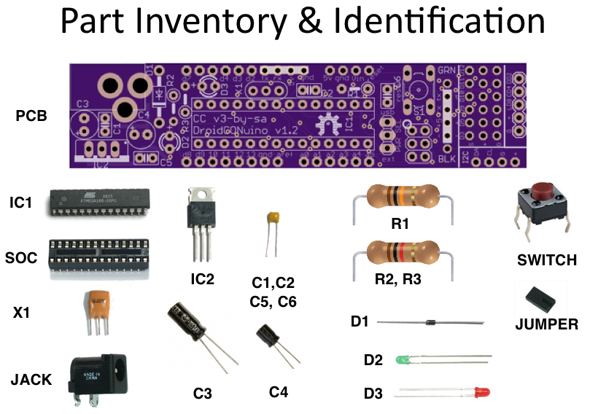

**Tools Needed:**

20 to 40 Watt Soldering Pen (~700 degrees)

Soldering Pen Holder – you don’t want a 700 degree pen rolling around and sliding off of the table and into your lap.

Wetted Sponge - Clean the tip after soldering each component or as needed

Flush Cutters - to trim the long leads close the PCBs, after components are soldered into place.

Solder 63/37 or 60/40 Diameter .31

Needle nose pliers may help as well.

**NOTE:** To make the PCB as small as possible, you will need to use a USB FTDI cable. This is the same cable used with IA-PARTS.com’s Magic Panel, Dome Bump Controller, R-Series Character Transmitter or with some XBee adapters. These are available from AdaFruit & SparkFun.

AdaFruit - https://www.adafruit.com/products/70

SparkFUN - https://www.sparkfun.com/products/9717

**Please check off the steps as you go.**

Wait HERE for some tips & techniques from the instructor…

**POWER SUPPLY Section**

Step 1 _____ Install Capacitors C1 & C5. (.1 uf 50V – Beige color) These capacitors are not polarized, so you don’t need to worry about which lead goes into which hole.

Step 2 _____ Install Capacitor C4 (100uF 6.3V – rather short). Please put the longer leg into the hole marked with + sign.

Step 3 _____ Install Capacitor C3 (47uF 25V – tallest capacitor). Please put the longer leg into the hole marked with + sign.

Step 4 _____ Install Diode D1 (1N4001). Insure you match the orientation of the diagram printed on the PCB.

Step 5 _____ Install 5V Regulator IC2 (7805CT). Match the orientation of the diagram printed on the PCB. Heatsink is nearest towards the outside of the PCB.

Step 6 _____ Install Resistor R2 (1k Ohm Brown-Black-RED-Gold).

Step 7 _____ Install LED D2 (3mm Green). Please put the longer leg into the hole marked with + sign.

Step 8 _____ Install Power JACK. It will fit only 1 way into the top of the PCB.

Step 9 _____ 1 x 3 Header, to be used as a Power Selector, shorter pin side goes into top of PCB. No polarity.

Step 10 _____ Install JUMPER on pin marked EXT and center.

Step 11 _____TEST Power Supply by connecting up to 12volts DC into the power JACK, a 9V DC battery works well. If all is well, the RED will illuminate. If not, troubleshoot. Otherwise, REMOVE POWER from JACK and you will be ready to continue.

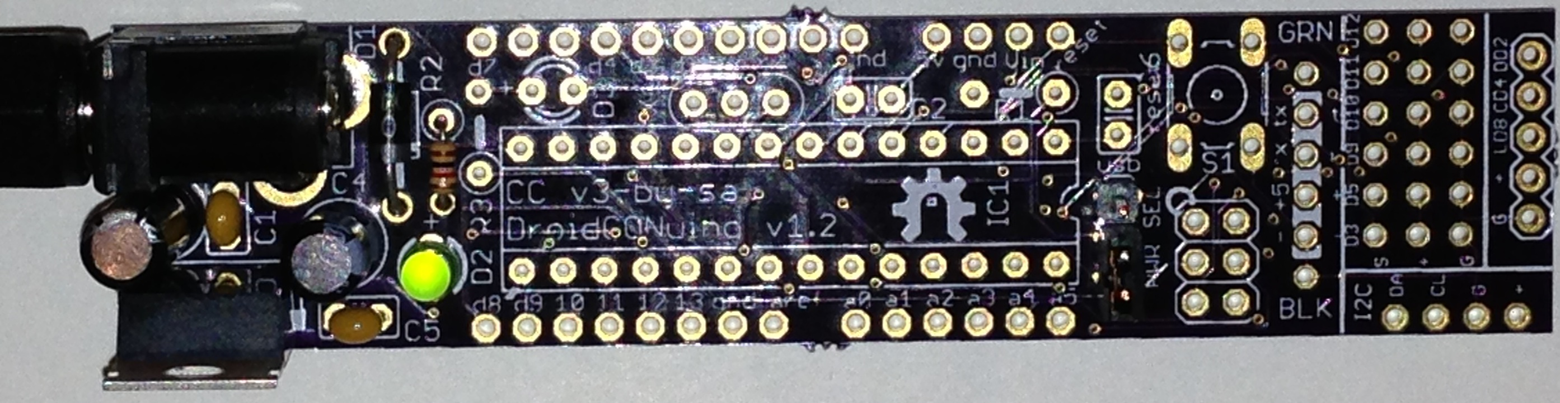

**MCU Section**

Step 12 _____ Install Resistor R3 (1k Ohm Brown-Black-RED-Gold).

Step 13 _____ Install LED D3 (3mm RED). Please put the longer leg into the hole marked with + sign.

Step 14 _____ Install X1, the 16MHz Resonator. Notice it has three leads, and is not polarized.

Step 15 _____ Install Resistor R1 (10k Ohm Brown-Black-ORANGE-Gold).

Step 16 _____ Install Capacitors C2 & C6. (.1 uf 50V – Beige color) These capacitors are not polarized.

Step 17 _____ Install SWITCH into top of PCB. Be careful to make sure that pins got into the holes, and SWITCH is firmly seated before soldering into place.

Step 18 _____ Install SOCKET into top of PCB. Align the indention at one end of the socket with the indention diagram on the PCB. Be careful to make sure that ALL pins got into the holes, and SOCKET is firmly seated. The SOCKET should “lock” onto the PCB. This will help you to solder it in. Try to keep your soldering neat.

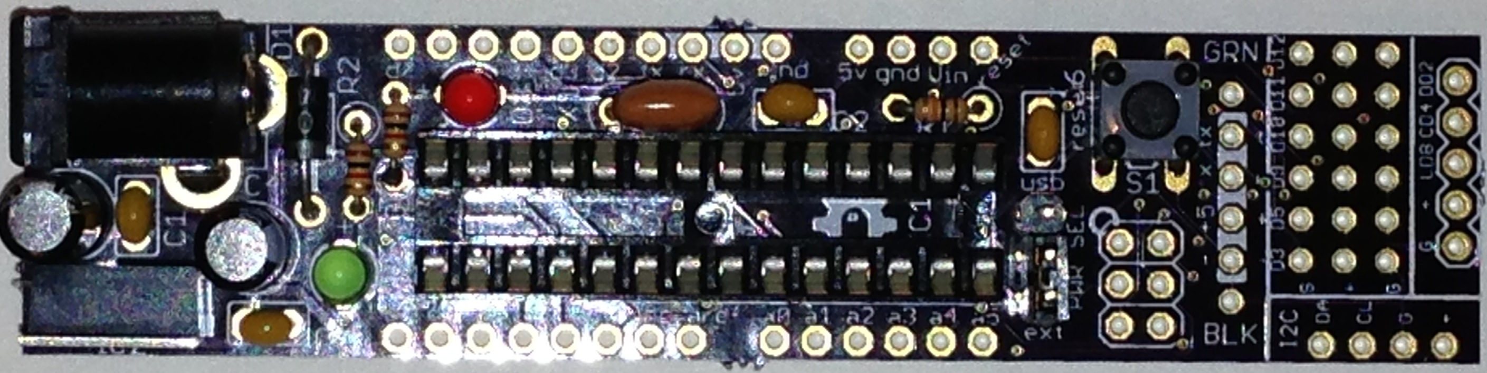

**Headers**

Step 19 _____ (OPTIONAL) - Install 2x3 header into ISCP section, onto TOP of PCB. (OPTIONAL)

Step 20 _____ Install 1x6 header into USB FTDI section, TOP of PCB. You will notice GRN at the top of the PCB and BLK at the bottom of the PCB. This is to help you install the FTDI cable into the PCB

Step 21 _____ Install 3x6 header into SERVO section, TOP of PCB.

Step 22 _____ Install 1x4 header into I2C section, TOP of PCB.

Step 23 _____ Install 1x5 header into LOGICS section, TOP of PCB.

Step 24 _____ (OPTIONAL) - Install header onto BREADBOARD, LONG leads down into the BREADBOARD to align with the holes remaining for using the DroidCONuino with a BREADBOARD.

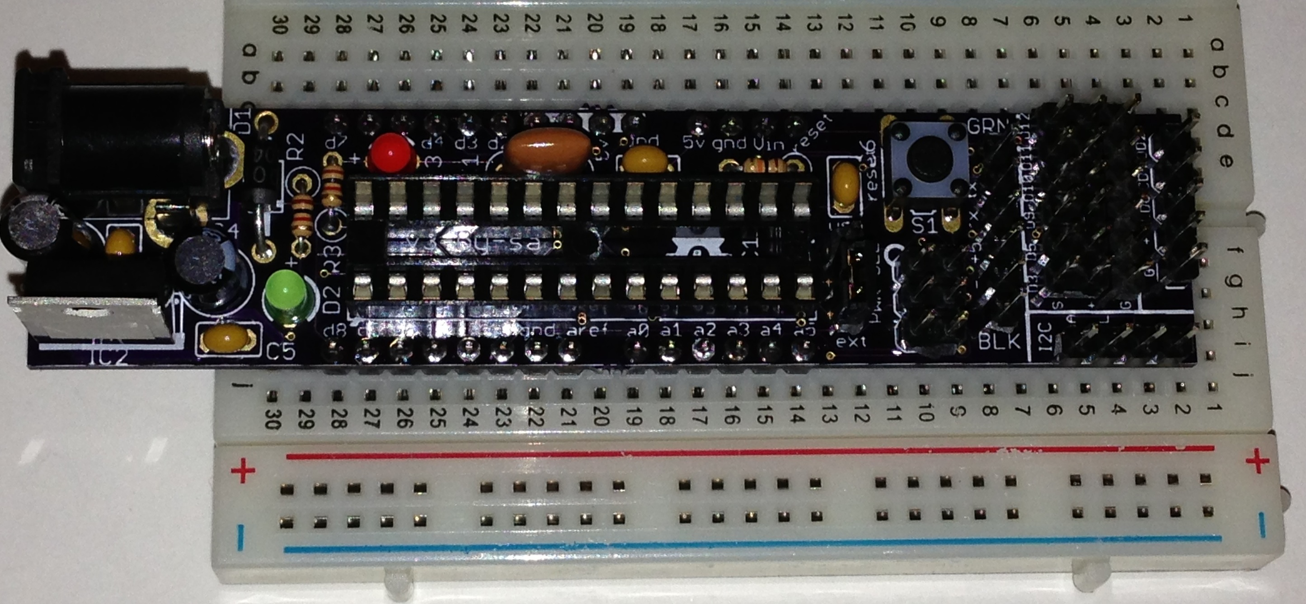

**Install MCU**

Step 25 _____ Ground yourself to dissipate any static buildup on your body. Not kidding here. You know those little “shocks” you get by sliding your feet on the carpet or handing a lot of styrene? That can easily be 50k volts, and those little static charges will fry sensitive components. The Atmel 328P micro controller CPU is sensitive to static.

Step 26 _____ Notice the 328P, which is installed onto static dissipating conductive foam. It has an indention on one end. This is called the top of the IC. The pin to the left of the indention is called Pin 1, and the pin to the right of the indention is Pin 28. Gently remove the 328P from the foam and set it into the IC socket aligning the indention on the CPU with the indention on the SOCKET, with the indention on the diagram.

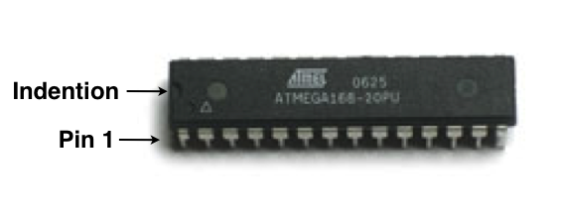

Step 27 _____ Verify all of the pins are lined up, and aligned with the corresponding pin sockets.

Step 28 _____ Gently apply pressure to both ends of the CPU, and the CPU will seat into the socket.

Step 29 _____ Verify all of the pins are properly in the corresponding pin sockets.

Step 30 _____ Verify the completed DroidCONuino looks like the following… or at least similar.

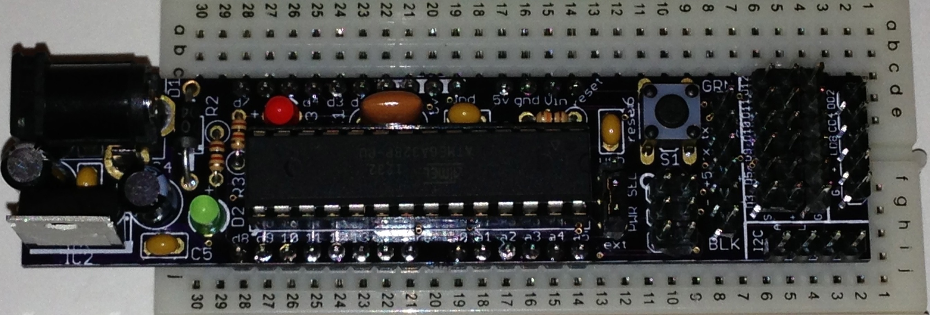

**Testing**

Step 31 _____ Apply up to 15v DC power into the 2.1mm JACK, and if everything is correct. The GREEN LED will illuminate

Step 32 _____ Press RESET Once and the RED LED should BLINK a few times.

Step 33 _____ Program the DroidCONuino via the FTDI connector. Notice GReeN & BLacK indicators.

Nam adipiscing ... by ædificantes.